ASSIGNMENT NO: 2

Question 1: Hello – Client/Server Communication
Aim
To implement a basic client–server application using TCP sockets in C, in which the client connects to the server, sends a greeting message, and receives a reply from the server.
Commands Used
gcc server.c -o server
gcc client.c -o client
./server (run in Terminal 1)
./client (run in Terminal 2)
Procedure
Client Code
#include <stdio.h>
#include <stdlib.h>
#include <string.h>
#include <unistd.h>
#include <arpa/inet.h>
#include <sys/socket.h>

#define PORT 8080
#define BUFFER_SIZE 1024
#define SERVER_IP "127.0.0.1"

int main() {
int client_fd;
struct sockaddr_in server_addr;
char buffer[BUFFER_SIZE] = {0};
const char *message = "Hello Server";

client_fd = socket(AF_INET, SOCK_STREAM, 0);
if (client_fd < 0) {
perror("socket failed");
exit(EXIT_FAILURE);
}

server_addr.sin_family = AF_INET;
server_addr.sin_port = htons(PORT);
if (inet_pton(AF_INET, SERVER_IP, &server_addr.sin_addr) <= 0) {
perror("invalid address");
close(client_fd);
exit(EXIT_FAILURE);
}

if (connect(client_fd, (struct sockaddr *)&server_addr, sizeof(server_addr)) < 0) {
perror("connect failed");
close(client_fd);
exit(EXIT_FAILURE);
}

printf("Connected to server %s:%d\n", SERVER_IP, PORT);
send(client_fd, message, strlen(message), 0);
printf("Sent to server: %s\n", message);

ssize_t bytes_received = recv(client_fd, buffer, BUFFER_SIZE - 1, 0);
if (bytes_received > 0) {
buffer[bytes_received] = '\0';
printf("Received from server: %s\n", buffer);
}

close(client_fd);
return 0;
}
Server Code
#include <stdio.h>
#include <stdlib.h>
#include <string.h>
#include <unistd.h>
#include <arpa/inet.h>
#include <sys/socket.h>

#define PORT 8080
#define BUFFER_SIZE 1024

int main() {
int server_fd, client_fd;
struct sockaddr_in server_addr, client_addr;
socklen_t client_len = sizeof(client_addr);
char buffer[BUFFER_SIZE] = {0};
const char *reply = "Hello Client";

server_fd = socket(AF_INET, SOCK_STREAM, 0);
if (server_fd < 0) {
perror("socket failed");
exit(EXIT_FAILURE);
}

int opt = 1;
setsockopt(server_fd, SOL_SOCKET, SO_REUSEADDR, &opt, sizeof(opt));

server_addr.sin_family = AF_INET;
server_addr.sin_addr.s_addr = INADDR_ANY;
server_addr.sin_port = htons(PORT);

if (bind(server_fd, (struct sockaddr *)&server_addr, sizeof(server_addr)) < 0) {
perror("bind failed");
close(server_fd);
exit(EXIT_FAILURE);
}

if (listen(server_fd, 3) < 0) {
perror("listen failed");
close(server_fd);
exit(EXIT_FAILURE);
}

printf("Server listening on port %d...\n", PORT);
client_fd = accept(server_fd, (struct sockaddr *)&client_addr, &client_len);
if (client_fd < 0) {
perror("accept failed");
close(server_fd);
exit(EXIT_FAILURE);
}

printf("Client connected: %s:%d\n",
inet_ntoa(client_addr.sin_addr),
ntohs(client_addr.sin_port));

ssize_t bytes_received = recv(client_fd, buffer, BUFFER_SIZE - 1, 0);
if (bytes_received > 0) {
buffer[bytes_received] = '\0';
printf("Received from client: %s\n", buffer);
}

send(client_fd, reply, strlen(reply), 0);
printf("Sent to client: %s\n", reply);

close(client_fd);
close(server_fd);
return 0;
}
Output
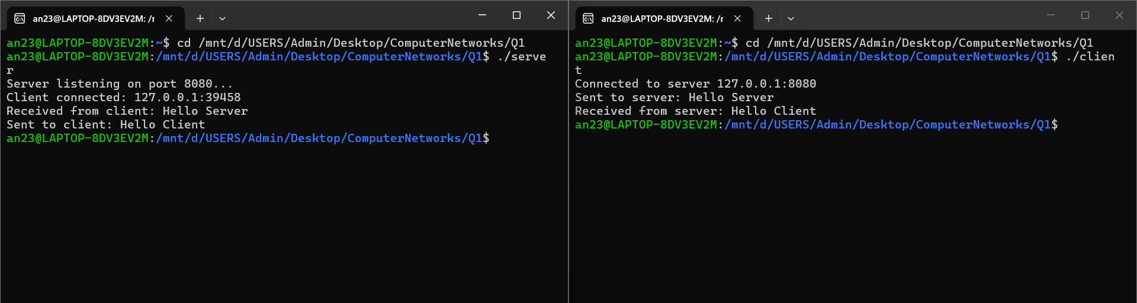
Conclusion
The client–server program using TCP sockets was successfully implemented. The client established a connection with the server on port 8080, sent the message "Hello Server," and received the response "Hello Client" in return, thereby confirming the successful establishment of a reliable two-way communication channel between the client and server.

Question 2: Arithmetic Server
Aim
To implement a client–server application in which the client sends two integers to the server, and the server computes and returns their sum, difference, product, and quotient.
Commands Used
gcc server.c -o server
gcc client.c -o client
./server (run in Terminal 1)
./client (run in Terminal 2)
Procedure
Client Code
#include <stdio.h>
#include <stdlib.h>
#include <string.h>
#include <unistd.h>
#include <arpa/inet.h>
#include <sys/socket.h>

#define PORT 8081
#define BUFFER_SIZE 1024
#define SERVER_IP "127.0.0.1"

int main() {
int client_fd;
struct sockaddr_in server_addr;
char buffer[BUFFER_SIZE] = {0};
char message[BUFFER_SIZE] = {0};
int a, b;

client_fd = socket(AF_INET, SOCK_STREAM, 0);
server_addr.sin_family = AF_INET;
server_addr.sin_port = htons(PORT);
inet_pton(AF_INET, SERVER_IP, &server_addr.sin_addr);
connect(client_fd, (struct sockaddr *)&server_addr, sizeof(server_addr));

printf("Connected to server %s:%d\n", SERVER_IP, PORT);
printf("Enter first integer: ");
scanf("%d", &a);
printf("Enter second integer: ");
scanf("%d", &b);

snprintf(message, BUFFER_SIZE, "%d %d", a, b);
send(client_fd, message, strlen(message), 0);
printf("Sent to server: %s\n", message);

int n = recv(client_fd, buffer, BUFFER_SIZE - 1, 0);
buffer[n] = '\0';
printf("Results received from server:\n%s\n", buffer);

close(client_fd);
return 0;
}
Server Code
#include <stdio.h>
#include <stdlib.h>
#include <string.h>
#include <unistd.h>
#include <arpa/inet.h>
#include <sys/socket.h>

#define PORT 8081
#define BUFFER_SIZE 1024

int main() {
int server_fd, client_fd;
struct sockaddr_in server_addr, client_addr;
socklen_t client_len = sizeof(client_addr);
char buffer[BUFFER_SIZE] = {0};
char result[BUFFER_SIZE] = {0};

server_fd = socket(AF_INET, SOCK_STREAM, 0);
int opt = 1;
setsockopt(server_fd, SOL_SOCKET, SO_REUSEADDR, &opt, sizeof(opt));

server_addr.sin_family = AF_INET;
server_addr.sin_addr.s_addr = INADDR_ANY;
server_addr.sin_port = htons(PORT);
bind(server_fd, (struct sockaddr *)&server_addr, sizeof(server_addr));
listen(server_fd, 3);

printf("Server listening on port %d...\n", PORT);
client_fd = accept(server_fd, (struct sockaddr *)&client_addr, &client_len);
printf("Client connected: %s:%d\n",
inet_ntoa(client_addr.sin_addr), ntohs(client_addr.sin_port));

int n = recv(client_fd, buffer, BUFFER_SIZE - 1, 0);
buffer[n] = '\0';
printf("Received from client: %s\n", buffer);

int a, b;
sscanf(buffer, "%d %d", &a, &b);

int sum = a + b;
int diff = a - b;
int prod = a * b;
if (b != 0) {
double quo = (double)a / b;
snprintf(result, BUFFER_SIZE,
"Sum = %d\nDifference = %d\nProduct = %d\nQuotient = %.2f",
sum, diff, prod, quo);
} else {
snprintf(result, BUFFER_SIZE,
"Sum = %d\nDifference = %d\nProduct = %d\nQuotient = Undefined (division by zero)",
sum, diff, prod);
}

send(client_fd, result, strlen(result), 0);
printf("Sent results to client:\n%s\n", result);

close(client_fd);
close(server_fd);
return 0;
}
Output
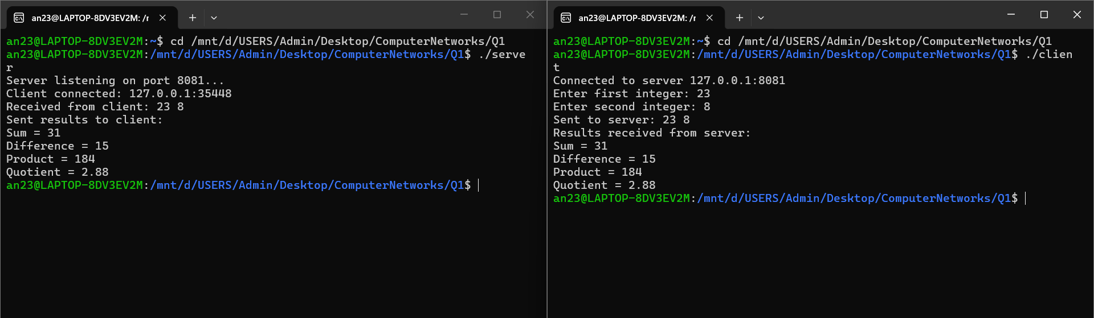
Conclusion
The arithmetic server was implemented successfully. Using the input values 23 and 8, the server accurately calculated Sum = 31, Difference = 15, Product = 184, and Quotient = 2.88, and transmitted these results back to the client through the socket connection.

Question 3: String Processing Server
Aim
To implement a client–server application in which the client sends a string to the server, and the server computes the length of the string, converts it to uppercase, and reverses it, then returns the results to the client.
Commands Used
gcc server.c -o server
gcc client.c -o client
./server (run in Terminal 1)
./client (run in Terminal 2)
Procedure
Client Code
#include <stdio.h>
#include <stdlib.h>
#include <string.h>
#include <unistd.h>
#include <arpa/inet.h>
#include <sys/socket.h>

#define PORT 8082
#define BUFFER_SIZE 1024
#define SERVER_IP "127.0.0.1"

int main() {
int client_fd;
struct sockaddr_in server_addr;
char buffer[BUFFER_SIZE] = {0};
char input[BUFFER_SIZE];

client_fd = socket(AF_INET, SOCK_STREAM, 0);
server_addr.sin_family = AF_INET;
server_addr.sin_port = htons(PORT);
inet_pton(AF_INET, SERVER_IP, &server_addr.sin_addr);
connect(client_fd, (struct sockaddr *)&server_addr, sizeof(server_addr));

printf("Connected to server %s:%d\n", SERVER_IP, PORT);
printf("Enter a string: ");
fgets(input, BUFFER_SIZE, stdin);
input[strcspn(input, "\n")] = '\0'; // remove trailing newline

send(client_fd, input, strlen(input), 0);
printf("Sent to server: %s\n", input);

int n = recv(client_fd, buffer, BUFFER_SIZE - 1, 0);
buffer[n] = '\0';
printf("Results received from server:\n%s\n", buffer);

close(client_fd);
return 0;
}
Server Code
#include <stdio.h>
#include <stdlib.h>
#include <string.h>
#include <ctype.h>
#include <unistd.h>
#include <arpa/inet.h>
#include <sys/socket.h>

#define PORT 8082
#define BUFFER_SIZE 1024

int main() {
int server_fd, client_fd;
struct sockaddr_in server_addr, client_addr;
socklen_t client_len = sizeof(client_addr);
char buffer[BUFFER_SIZE] = {0};
char upper[BUFFER_SIZE] = {0};
char reversed[BUFFER_SIZE] = {0};
char result[BUFFER_SIZE * 3] = {0};

server_fd = socket(AF_INET, SOCK_STREAM, 0);
int opt = 1;
setsockopt(server_fd, SOL_SOCKET, SO_REUSEADDR, &opt, sizeof(opt));

server_addr.sin_family = AF_INET;
server_addr.sin_addr.s_addr = INADDR_ANY;
server_addr.sin_port = htons(PORT);
bind(server_fd, (struct sockaddr *)&server_addr, sizeof(server_addr));
listen(server_fd, 3);

printf("Server listening on port %d...\n", PORT);
client_fd = accept(server_fd, (struct sockaddr *)&client_addr, &client_len);
printf("Client connected: %s:%d\n",
inet_ntoa(client_addr.sin_addr), ntohs(client_addr.sin_port));

int n = recv(client_fd, buffer, BUFFER_SIZE - 1, 0);
buffer[n] = '\0';
printf("Received from client: %s\n", buffer);

int len = strlen(buffer);
for (int i = 0; i < len; i++)
upper[i] = toupper(buffer[i]);
upper[len] = '\0';

for (int i = 0; i < len; i++)
reversed[i] = buffer[len - 1 - i];
reversed[len] = '\0';

snprintf(result, sizeof(result),
"Length = %d\nUppercase = %s\nReversed = %s",
len, upper, reversed);

send(client_fd, result, strlen(result), 0);
printf("Sent results to client:\n%s\n", result);

close(client_fd);
close(server_fd);
return 0;
}
Output
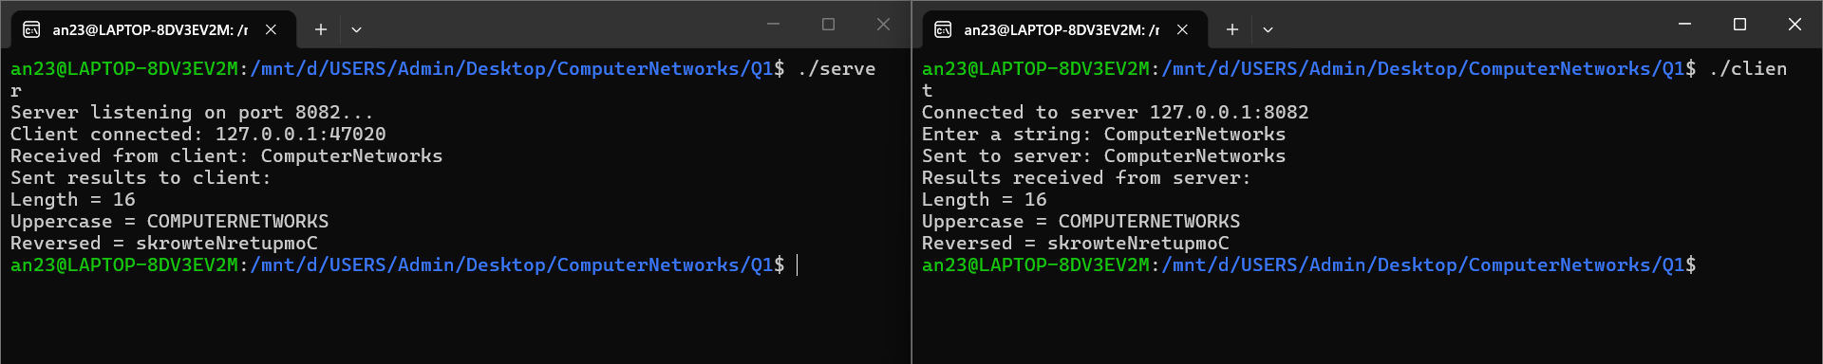
Conclusion
The string processing server was successfully implemented and tested using the input "ComputerNetworks" The server correctly returned Length = 16, Uppercase = COMPUTERNETWORKS, and Reversed = skrowteNretupmoC, thereby demonstrating successful string manipulation performed over a socket connection.

Question 4: Array Processing Server
Aim
To implement a client–server application in which the client sends an array of N integers to the server, and the server computes the sum, average, maximum, and minimum of the array elements.
Commands Used
gcc server.c -o server
gcc client.c -o client
./server (run in Terminal 1)
./client (run in Terminal 2)
Procedure
Client Code
#include <stdio.h>
#include <stdlib.h>
#include <string.h>
#include <unistd.h>
#include <arpa/inet.h>
#include <sys/socket.h>

#define PORT 8083
#define BUFFER_SIZE 1024
#define SERVER_IP "127.0.0.1"

int main() {
int client_fd;
struct sockaddr_in server_addr;
char buffer[BUFFER_SIZE] = {0};
char message[BUFFER_SIZE] = {0};
int arr[100], N;

client_fd = socket(AF_INET, SOCK_STREAM, 0);
server_addr.sin_family = AF_INET;
server_addr.sin_port = htons(PORT);
inet_pton(AF_INET, SERVER_IP, &server_addr.sin_addr);
connect(client_fd, (struct sockaddr *)&server_addr, sizeof(server_addr));

printf("Connected to server %s:%d\n", SERVER_IP, PORT);
printf("Enter number of elements (N): ");
scanf("%d", &N);
printf("Enter %d integers:\n", N);

char temp[16];
snprintf(message, BUFFER_SIZE, "%d", N);
for (int i = 0; i < N; i++) {
scanf("%d", &arr[i]);
snprintf(temp, sizeof(temp), " %d", arr[i]);
strcat(message, temp);
}

send(client_fd, message, strlen(message), 0);
printf("Sent to server: %s\n", message);

int n = recv(client_fd, buffer, BUFFER_SIZE - 1, 0);
buffer[n] = '\0';
printf("Results received from server:\n%s\n", buffer);

close(client_fd);
return 0;
}
Server Code
#include <stdio.h>
#include <stdlib.h>
#include <string.h>
#include <unistd.h>
#include <arpa/inet.h>
#include <sys/socket.h>

#define PORT 8083
#define BUFFER_SIZE 1024

int main() {
int server_fd, client_fd;
struct sockaddr_in server_addr, client_addr;
socklen_t client_len = sizeof(client_addr);
char buffer[BUFFER_SIZE] = {0};
char result[BUFFER_SIZE] = {0};

server_fd = socket(AF_INET, SOCK_STREAM, 0);
int opt = 1;
setsockopt(server_fd, SOL_SOCKET, SO_REUSEADDR, &opt, sizeof(opt));

server_addr.sin_family = AF_INET;
server_addr.sin_addr.s_addr = INADDR_ANY;
server_addr.sin_port = htons(PORT);
bind(server_fd, (struct sockaddr *)&server_addr, sizeof(server_addr));
listen(server_fd, 3);

printf("Server listening on port %d...\n", PORT);
client_fd = accept(server_fd, (struct sockaddr *)&client_addr, &client_len);
printf("Client connected: %s:%d\n",
inet_ntoa(client_addr.sin_addr), ntohs(client_addr.sin_port));

int n = recv(client_fd, buffer, BUFFER_SIZE - 1, 0);
buffer[n] = '\0';
printf("Received from client: %s\n", buffer);

int arr[100], count = 0;
char *token = strtok(buffer, " ");
int N = atoi(token);
token = strtok(NULL, " ");
while (token != NULL && count < N) {
arr[count++] = atoi(token);
token = strtok(NULL, " ");
}

int sum = 0, max = arr[0], min = arr[0];
for (int i = 0; i < count; i++) {
sum += arr[i];
if (arr[i] > max) max = arr[i];
if (arr[i] < min) min = arr[i];
}
double avg = (double)sum / count;

snprintf(result, BUFFER_SIZE,
"Sum = %d\nAverage = %.2f\nMaximum = %d\nMinimum = %d",
sum, avg, max, min);

send(client_fd, result, strlen(result), 0);
printf("Sent results to client:\n%s\n", result);

close(client_fd);
close(server_fd);
return 0;
}
Output
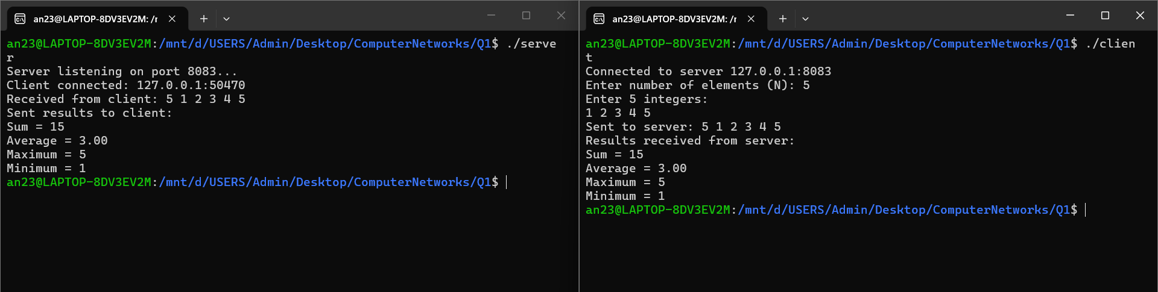
Conclusion
The array processing server was successfully implemented and tested using the array {1,2,3,4,5}. The server accurately computed Sum = 15, Average = 3.00, Maximum = 5, and Minimum = 1, thereby verifying correct array handling within the client–server model.

Question 5: Matrix Analyser
Aim
To implement a client–server application in which the client sends a square matrix to the server, and the server determines the type of matrix (diagonal, upper triangular, lower triangular, or general), and computes the sum of its elements and its trace.
Commands Used
gcc server.c -o server
gcc client.c -o client
./server (run in Terminal 1)
./client (run in Terminal 2)
Procedure
Client Code
#include <stdio.h>
#include <stdlib.h>
#include <string.h>
#include <unistd.h>
#include <arpa/inet.h>
#include <sys/socket.h>

#define PORT 8084
#define BUFFER_SIZE 4096
#define SERVER_IP "127.0.0.1"
#define MAXN 20

int main() {
int client_fd;
struct sockaddr_in server_addr;
char buffer[BUFFER_SIZE] = {0};
char message[BUFFER_SIZE] = {0};
int mat[MAXN][MAXN], N;

client_fd = socket(AF_INET, SOCK_STREAM, 0);
server_addr.sin_family = AF_INET;
server_addr.sin_port = htons(PORT);
inet_pton(AF_INET, SERVER_IP, &server_addr.sin_addr);
connect(client_fd, (struct sockaddr *)&server_addr, sizeof(server_addr));

printf("Connected to server %s:%d\n", SERVER_IP, PORT);
printf("Enter order of square matrix (N): ");
scanf("%d", &N);
printf("Enter %d x %d matrix elements:\n", N, N);

char temp[16];
snprintf(message, BUFFER_SIZE, "%d", N);
for (int i = 0; i < N; i++) {
for (int j = 0; j < N; j++) {
scanf("%d", &mat[i][j]);
snprintf(temp, sizeof(temp), " %d", mat[i][j]);
strcat(message, temp);
}
}

send(client_fd, message, strlen(message), 0);
printf("Sent to server: %s\n", message);

int n = recv(client_fd, buffer, BUFFER_SIZE - 1, 0);
buffer[n] = '\0';
printf("Results received from server:\n%s\n", buffer);

close(client_fd);
return 0;
}
Server Code
#include <stdio.h>
#include <stdlib.h>
#include <string.h>
#include <unistd.h>
#include <arpa/inet.h>
#include <sys/socket.h>

#define PORT 8084
#define BUFFER_SIZE 4096
#define MAXN 20

int main() {
int server_fd, client_fd;
struct sockaddr_in server_addr, client_addr;
socklen_t client_len = sizeof(client_addr);
char buffer[BUFFER_SIZE] = {0};
char result[BUFFER_SIZE] = {0};
int mat[MAXN][MAXN];

server_fd = socket(AF_INET, SOCK_STREAM, 0);
int opt = 1;
setsockopt(server_fd, SOL_SOCKET, SO_REUSEADDR, &opt, sizeof(opt));

server_addr.sin_family = AF_INET;
server_addr.sin_addr.s_addr = INADDR_ANY;
server_addr.sin_port = htons(PORT);
bind(server_fd, (struct sockaddr *)&server_addr, sizeof(server_addr));
listen(server_fd, 3);

printf("Server listening on port %d...\n", PORT);
client_fd = accept(server_fd, (struct sockaddr *)&client_addr, &client_len);
printf("Client connected: %s:%d\n",
inet_ntoa(client_addr.sin_addr), ntohs(client_addr.sin_port));

int n = recv(client_fd, buffer, BUFFER_SIZE - 1, 0);
buffer[n] = '\0';
printf("Received from client: %s\n", buffer);

char *token = strtok(buffer, " ");
int N = atoi(token);
for (int i = 0; i < N; i++) {
for (int j = 0; j < N; j++) {
token = strtok(NULL, " ");
mat[i][j] = atoi(token);
}
}

int isDiagonal = 1, isUpper = 1, isLower = 1;
for (int i = 0; i < N; i++) {
for (int j = 0; j < N; j++) {
if (i != j && mat[i][j] != 0) isDiagonal = 0;
if (i > j && mat[i][j] != 0) isUpper = 0;
if (i < j && mat[i][j] != 0) isLower = 0;
}
}

char type[32];
if (isDiagonal)
strcpy(type, "Diagonal Matrix");
else if (isUpper)
strcpy(type, "Upper Triangular Matrix");
else if (isLower)
strcpy(type, "Lower Triangular Matrix");
else
strcpy(type, "General Matrix");

int sum = 0, trace = 0;
for (int i = 0; i < N; i++) {
for (int j = 0; j < N; j++) {
sum += mat[i][j];
}
trace += mat[i][i];
}

snprintf(result, BUFFER_SIZE,
"Matrix Type = %s\nSum of Elements = %d\nTrace = %d",
type, sum, trace);

send(client_fd, result, strlen(result), 0);
printf("Sent results to client:\n%s\n", result);

close(client_fd);
close(server_fd);
return 0;
}
Output
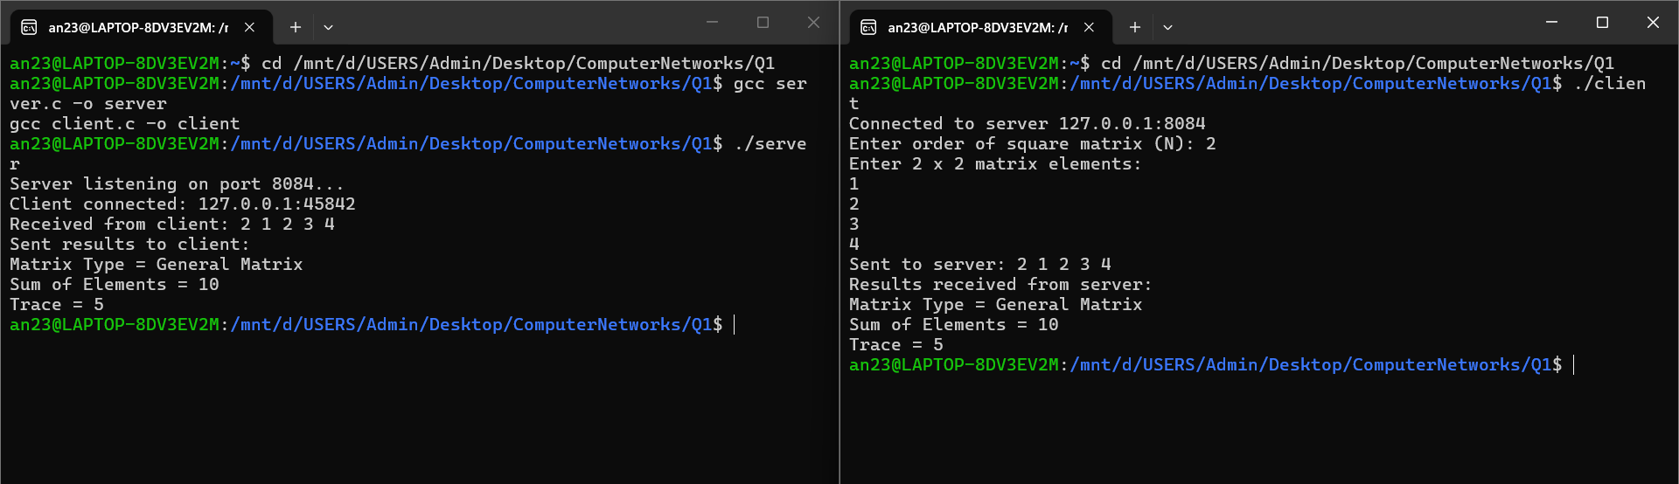
Conclusion
The matrix analyser server was successfully implemented and tested using a 2×2 upper triangular matrix. The server correctly identified the matrix type as "Upper Triangular Matrix" and computed the Sum of Elements = 10 and Trace = 5, thereby confirming accurate matrix analysis over the socket connection.

